RUTHERGLEN HIGH SCHOOL COMPUTER USER AGREEMENT

Purpose

DET ICT systems must be properly and efficiently used. DET ICT systems are not to be used for inappropriate activities for example, pornography, fraud, defamation, breach of copyright, unlawful discrimination or vilification, sexual harassment, stalking, illegal activity and privacy violations.

User Agreement

The computer network has been provided to support the educational program of the school and to improve student learning. All computer usage and Internet access is to directly relate to educational curriculum aspects. Prior to logging onto computers, students are required to accept the condition of this agreement.

Network User Responsibilities.

Users are to use the network as it is currently formatted. The following are breaches of this responsibility:

- Unauthorised manipulations of software and/or the standard operating system.
- Running of illegal software or files.
- Using school equipment for piracy and breaches of copyright, such as P2P software and illegal copying.
- Interference with another person's access rights or user area.
- Use or storage of inappropriate material in the user area or on an external storage device.
- Hiding the task bar.
- Allowing others to access the network, Internet or email through their own workspaces.
- Accessing the network, Internet or email in any way except through their own workspaces using their own password.

Failure to meet these responsibilities may result in loss of computer network access in the school.

Internet

- The Internet may only be used for school purposes.
- Students must not log on to the Internet during class time unless under the direct instruction of the teacher.
- Students have the responsibility to not open sites or documents they realise are inappropriate.
- Students are to inform the teacher immediately if they inadvertently open inappropriate sites or documents.

Library

- During class time, classes booked into the library have priority for computer usage. If there are spare computers, these may be used by other students.
- During lunchtime, computers may be used for school work or program use approved by the staff member in charge.
- Internet use is only available for school based research.

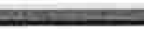

Lunch Time/After school

- Students are not to enter computer rooms or use computers in classrooms unless a teacher is present. (This includes senior students.)
- Students requiring access to complete assignments must have written permission from the class teacher to be given priority for computer use.
- Permission for computer use must be obtained from the supervising teacher
- On occasion, rooms will be opened for games that are approved by the ICT Network Manager. These games will comply with the appropriate guidelines, i.e. No 15+ games, illegal games, excessive violence or inappropriate content etc.

Electronic Mail

Electronic Mail is to be used only for school purposes.

- Email, Hotmail or Other Electronic Mail messages to be sent or read only after seeking permission from the supervising teacher.
- On-line etiquette and protocol should be observed at all times.

External Storage Devices

- External storage devices are to be used only for schoolwork, back-up copies and homework and to be used under teacher supervision.
- The school maintains the right to inspect the information stored on these devices.

Scanner

Scanners are to be used only for school related material and under the direct supervision of a teacher. Use of scanners can infringe on copyright and so the user must ensure such breaches do not occur.

Consequences of misuse/ abuse of privileges

- Abuse of internet privileges will lead to a ban of 1 week for a first offence.
- Continued refusal to comply with the Computer User Policy or Staff requests relating to ICT use will result in a total ban from computer use for 1 week.
- Deliberate damage to hardware and / or software will result in a loss of computer privileges for 2 weeks then reassessed by the relevant staff. Students will be required to pay for the repair or replacement of damaged hardware and/or the cost of a technician to rectify the issue.
- Each case will be viewed and passed on to Year Level Coordinators as appropriate. Discussions with relevant coordinators/ teachers for appropriate/ further action will also occur for any infringements.

Please complete attached consent/agreement form at the end of this package.

Rutherglen High School

ACTING PRINCIPAL: Ms Cassandra Walters Email: rutherglen.hs@education.vic.gov.au Internet: http://www.rutherglenhs.vic.edu.au
PO Box 84, Rutherglen, Vic, 3685
Phone: 02) 6032 9483
FAX: 02) 6032 9185

Consent for publishing a student image - Intranet/ Website/ Publications

Name of person requesting Permission: Ms Cassandra Walters

Permission is being requested to publish images of the nominated student on the school's intranet for students and teachers to access at school and home, the school's publicly accessible website, and in publications such as the school newsletter, brochures, magazines, newspapers and other promotional materials.

The Rutherglen High School website address is: http://www.rutherglenhs.vic.edu.au

The consent sought is for an indefinite period of time. Consent may be withdrawn at any time, in writing forwarded to the Principal Class at Rutherglen High School.

Yours sincerely,
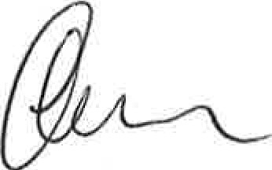
Cassandra Walters Acting Principal

Please complete attached consent/agreement form at the end of this package.

<f> Rutherglen High School

ACTING PRINCIPAL: Ms Cassandra Walters Email: rutherglen.hs@education.vic.gov.au Internet: http://www.rutherglenhs.vic.edu.au
PO Box 84, Rutherglen, Vic, 3685
Phone: 02) 6032 9483
FAX: 02) 6032 9185

Consent to request reports and information from feeder primary school

Dear Parent/Guardian

In order to develop a full picture of your child's academic and social progress, Rutherglen High School would like to receive copies of your child's last Primary School report (and any other information that may assist in their transition to High School). These reports will be confidentially filed and used by teachers to better personalise the curriculum provided to your child.

Please sign the attached consent /agreement form at the end of this package to indicate that you are happy for the Primary School to forward a copy of this report to the school or indicate if you would prefer that Rutherglen High School make direct contact with you to discuss such matter.

Thank you in anticipation of you support and assistance in this matter.

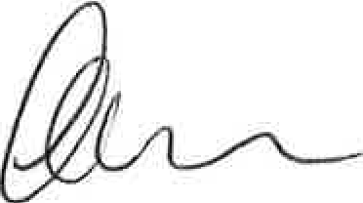
Yours sincerely
Cassandra Walters Acting Principal

Please complete attached consent/agreement form at the end of this package.

Rutherglen High School

ACTING PRINCIPAL: Ms Cassandra Walters Email: rutherglen.hs@education.vic.gov.au Internet: http://www.rutherglenhs.vic.edu.au
PO Box 84, Rutherglen, Vic, 3685
Phone:02)60329483 FAX: 02) 6032 9185

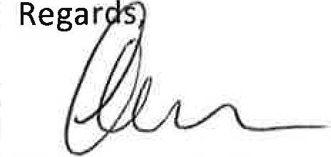

2023/24 Notice of Insurance Situation

Dear Parents/ Guardians,

Please note that Rutherglen High School does not have Student Insurance.

School Injuries and Insurance

Parents and guardians are generally responsible for paying the cost of medical treatment for injured students, including any transport costs. Most medical costs will be refundable by Medicare. If you are a member of an ambulance or health insurance fund, you may also be able to claim transport or other expenses from the fund.

The Department of Education and Training does not hold accident insurance for school students.

Is other insurance cover available? Yes.
The Department is aware of two insurers, JUA Underwriting Agency Pty Ltd and Willis Australia Ltd. that provide accident insurance policies for students. These policies provide specific benefits for students who are injured in accidents for a reasonably low cost. Other insurers may also do so.

If you need any further assistance, please contact the General Office on 02 6032 9483.

Cassandra Walters Acting Principal

Please complete attached consent/agreement form at the end of this package.

Rutherglen High School

ACTING PRINCIPAL: Ms Cassandra Walters Email: rutherglen.hs@education.vic.gov.au Internet: http://www.rutherglenhs.vic.edu.au
PO Box 84, Rutherglen, Vic, 3685
Phone: 02) 6032 9483
FAX: 02} 6032 9185

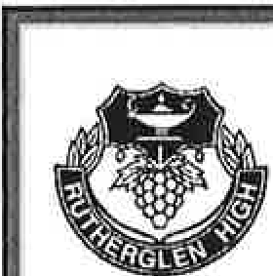
Rules and expectations regarding valuables, laptops, phones etc.

Dear Parents/ Guardians,

Increasingly students bring valuable items to school. While the school and staff exercise great care, neither the school nor individual staff are responsible for these valuables. Students are provided with a locker and a combination lock and students should ensure lockers remain securely locked and they do not share their combination code with others.

There are specific school rules in this area:

Mobile Phones:
Mobile phones are not to be brought to school. Phones required for use after school use should be placed in the General Office and collected after school.
Phones confiscated must be collected by a parent/guardian.

Laptops and similar devices:
The school has moved to a Bring Your Own Device (BYOD) program. The school provides secure lockers for storage of such devices. However, the student is responsible for looking after the device.
The school recommends the family having insurance for such a device being lost, stolen or damaged.

Other valuables including cash:
Apart from small amounts of money for use in the Canteen, the school recommends students do NOT bring cash or valuables such as jewellery to school. If for any reason valuables or cash are brought to school, we recommend that they be taken to the General Office for safe-keeping.
While the school will assist in trying to recover lost or stolen valuables, we are not responsible for such losses.

Cassandra Walters Acting Principal

Please complete attached consent/agreement form at the end of this package.

4r, Rutherglen High School

ACTING PRINCIPAL: Ms Cassandra Walters Email: rutherglen.hs@education.vlc.gov.au Internet: http://www. rutherglenhs.vie.edu.au

Consent and Agreement Form
PO Box 84, Rutherglen, Vic, 3685
Phone: 02 6032 9483
FAX: 02 6032 9185

Computer Use Agreement:

I have read and agree to comply with the Rutherglen High School Computer Use Agreement. I acknowledge that if I do not comply with this agreement then consequences including being banned from use of devices and the network and/or repair or replacement costs will result.

Consent for publishing a student image:
I do/do not give permission to Rutherglen High School to publish images of my child on the Rutherglen High School intranet for student and teachers to access at school, home and publicly accessible website. Please note: Forms not indicating a preference will be deemed approved

Consent for requesting information from feeder primary school (if applicable - Yr 6 into Yr 7):
□

I give my permission and support to seek relevant information and school reports from Primary School to assist in their transition to high school.
□
OR

I request that Rutherglen High School makes direct contact with me to access recent school reports.

Acknowledgement of Notice of Insurance Situation.

I have read the attached notice informing me that Rutherglen High School does NOT have Student Insurance. I am aware that I can take out private student insurance at my expense.

Acknowledgement of Notice regarding valuables including laptops, phones etc.

I have read the attached notice informing me of the rules and expectations regarding valuables including laptops, phones etc. I acknowledge that while the school will provide secure lockers and storage options such storing valuables at the General Office, the student remains responsible for the safety of the valuables. I am also aware the school recommends taking out insurance for laptops etc.

In signing this form I agree I have read the information attached and have:
- Agreed to comply with the Computer Use Agreement
- Indicated whether or not I consent to the publishing of a student image
- Indicated whether or not I consent to RHS directly contact the feeder primary school for transition information including student reports
- Acknowledged that Rutherglen does NOT have Student Insurance.
- Acknowledged that responsibility for safety and security of valuables remains with the student

Student Name: -------
Parent Name: _
Student Signature: _ Parent Signature: _
Date:_/_/_ Date:_/_/_

